**A compact Umbrella shaped Planar and Stretchable Ultra Wide Band Antenna with quad Circular Slots for Bio-medical applications**

Dr. Vinod Kumar Singh | Er. Neeraj Kumar | Shalini Upadhyay | Nidhi Patel | Chandan Maddheshiya | Ritik Viswakarma | Sumit Narayan Singh |

**Abstract:** The usage of Wearable devices and products is currently increasing in biomedical field. The presented antenna is suitable for monitoring, alerting and demanding attention during any hospital emergency. This ultra-wide band (UWB) flexible umbrella shape body worn antenna is fabricated on a jean’s material as a substrate. The incarnated antenna has a -10dB measured impedance band width of 1309MHz.The antenna size is 64.2 × 77.2 mm2 . The radiation effect emitted by the presented antenna on the human body is given by the calculation of specific absorption rate (SAR) value. The result in terms of band width, return loss, radiation pattern along with gain and efficiency are presented to validate functionality of current proposed design.

**Key Words:** Ultra-wide band, body worn antenna, efficiency, textile antenna, return loss, SAR.

1. **Introduction**

Wearable computing is a fast-growing field in application based research [1]. This technology which allows devices to be worn directly on the body or embedded in clothing when designed on textile, should have low dielectric constant which in result improves the impedance band width of the antenna. The textile material that we are using can either be artificial man-made or natural fibers, the jeans material is a synthetic man-made fibre. The important properties can be calculated using simulation software Computer Simulation Technology (CST) microwave studio suite.

Ultra-wide band is a showing up wireless technology approved by Federal Communications Commission (FCC) for commercial use of frequency band from 3.1to 10.6 GHz.UWB antennas have several applications such as biomedical, microwave imaging, internet of thing and wireless local area network. Over a period of time, flexible antennas have been used for producing microwave imaging by placing on the human body surface for biomedical application. Due to difference in dielectric properties of healthy and baleful tissues, the electromagnetic wave interacts and they produce different microwave images a circular shape radiator UWB is presented, which is design with 100% cloth for body-oriented wireless application. Since, it is design on cloth it can be washed if the conductive part is made up of conductive thread available in market.

The proposed simulation explains the design of compact low cast, flexible, high gain and efficiency antenna with UWB range which will be fabricated on cloth for health monitoring functions. The basic shape of antenna is semi-circular because circular shape antennas have better performance than rectangular shape antenna [2]. The patch we have selected resembles umbrella, which can be easily designed and implanted on cloth. One of the measure characteristics that must be taken in consideration by any wearable antenna is the low specific absorption rate [3] [4].

It is necessary to measure and evaluate SAR because human body will absorb and get affected by the back radiation emitted by the antenna.

The rest of the paper is planned as follows. It majorly has five more sections divided. The design of UWB antenna detail is discussed in section II. This section comprises of Antenna description and simulation environment. The performance analysis, surface current and radiation pattern, banding effect is described in section III, IV and V respectively. Finally, the main conclusions and further work is discussed in last section.

1. **Antenna design**
2. **Antenna description**

The umbrella shaped antenna is made out from a basic circular patch. To increase the bandwidth of basic circular patch antenna with narrow bandwidth, slots can be embedded and defected ground technique on the periphery of the patch antenna can be used. [5] [6] The substrate of the proposed antenna is made of jeans of thickness 1mm. The reason behind using jeans as a substrate is that in enhances bandwidth and reduces the surface wave losses due to its low dielectric constant [7] [8] . The overall dimension of the antenna is 65.2 × 78.2 × 1 mm3 **.**The radius of the Patch is calculated as per Equation (1) [9] [10].

(1)

The dielectric permittivity (Ɛr),thickness(t) and loss tangent(tanδ) values are shown in Table 1.

|  |
| --- |
| Textile material Values |
| Measured dielectric permittivity 1.76 |
| Thickness 1mm |
| Loss tangent 0.025 |

**Case 1 Case 2** **Case 3 Case 4 (Proposed)**

**(A)**

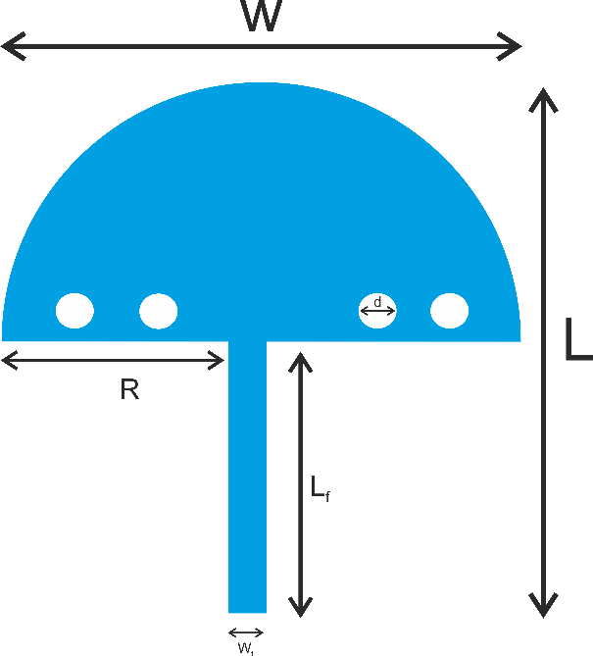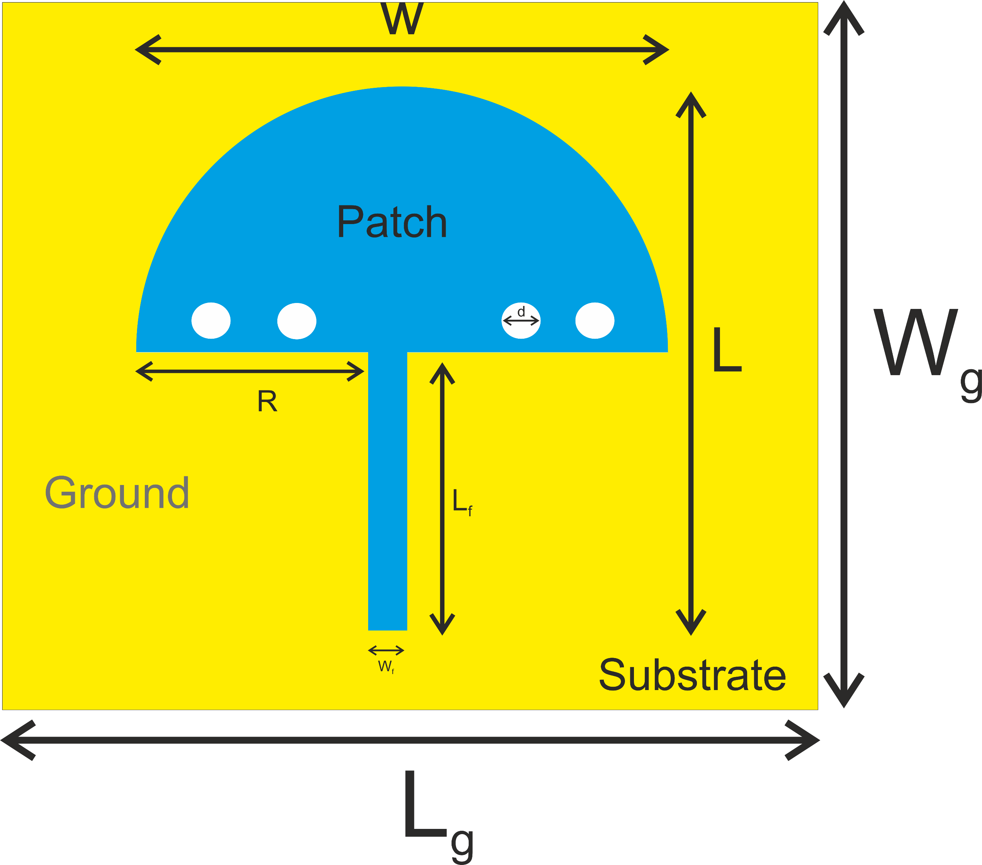

**(B) (C)**

FIGURE 1 Simulation models (A) Design steps (B) Parametric view(C) Back view.

The patch antenna is designed in four steps to get the final suitable umbrella for ultrawide band. Figure 1A shows four design steps and geometry to achieve the required shape. The geometry of the proposed antenna is shown in Figure 1B.

Considering to Figure 1A, in case 1 we have designed a conventional circular patch antenna with a radius of 23mm. In case 2 we have cut it out to get a semi-circular patch for better bandwidth. Moving ahead in case 3 to get multiple resonance frequency, two slots of diameter 10mm are cut out on the semicircular patch. In last case two more slots are added and we have our final proposed design with 4 embedded slots on the semi-circular patch.

Figure 1B shows the parameters mentioned in Table 2. Figure 1C shows the final front view of the antenna.

Table 2 Parameters of proposed design

|  |  |  |  |  |
| --- | --- | --- | --- | --- |
| **Parameter** | **L** | **W** | **R** | **d** |
| Value (mm) | 78.2 | 65.2 | 23 | 10 |
| **Parameters** | **Lf** | **Wf** | **Lg** | **Wg** |
| Value (mm) | 49.6 | 2.5 | 78.2 | 65.2 |

1. **Performance analysis**

Here CST softwareis used for simulation of the antenna. The simulation results are shown further the designed antenna has a simulated impedance bandwidth from 2.9GHz to 18GHz with three resonance frequencies: f1= 3.14 GHz, f2=4.42 GHz and f3=10.71 GHz.The antenna that we have design has enhanced impendence bandwidth and serves the purpose.

FIGURE 2 Simulated Return Loss of designed antenna.

By varying different parameters and performing the parametric study we have compared the characteristics of the proposed antenna and tried to enhance the performance.

1. **Variation in width of feed-line of the antenna**

The **e**ffect of varying feed width between 1.4mm to 2.5mm at a fixed value of feed length (Lf =49.6mm) on return loss characteristic is shown in figure 3. The antenna shows variations an archives multiband operation with the change in value of feedline, the bandwidth is improved at width of 2.5mm. Hence, 2.5mm is the optimum value for feed-line suitable for fabricated prototype.

FIGURE 3 Return loss curves for feed width (Wf)

1. **Variation in length of feed-line of the antenna**

The result for return loss for different values of feed length (Lf) at fixed value of feed width (Wf) is represented in figure 4 the antenna shows very minimal variation so, here optimum value is chosen as 49.6mm to get the required bandwidth.

FIGURE 4 Return loss curves for feed width (Lf)

1. **Variation in size of ground plane of the antenna**

The result obtained by varyingthe size of ground plane at fixed value of feed length and feed width is presented in figure 5. The band width is quiet good for full length ground plane. So Lg=78.2mm is the optimum value for length of ground plane.

FIGURE 5 Return loss curve for ground plane.

1. **Variation in radius of Patch of the antenna**

The deviation of return loss for different values of radius (R) is presented in figure 6. The radius is varied between 23mm to 27mm keeping all other parameters fixed. For higher value of radius the resonant frequency is shifted. So 23mm is a suitable vale for radius of patch to get required results.

FIGURE 6 Return loss cure for radius of patch.

1. **Surface current and radiation pattern**

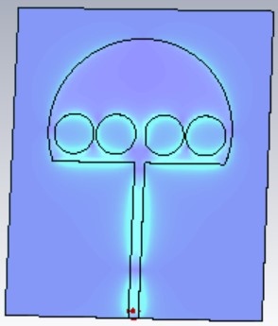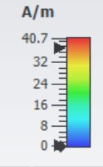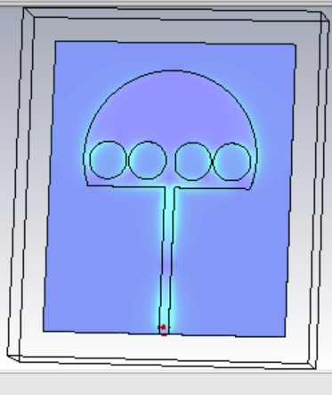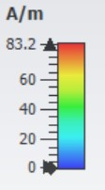

1. **(B)**

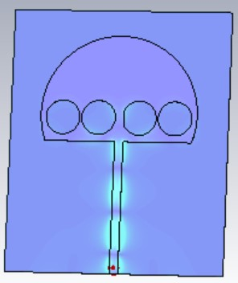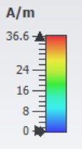

**(C)**

FIGURE 7 Simulated surface current at (A) 3.14 GHz (B) 4.42 GHz (C) 10.71 GHz

The current density of the preposed antenna at resonant frequency at f1=3.14, f2= 4.42 and f3=10.17 is given in figure 7. At 3.14 GHz , it can be seen that most of current having amplitude 83.2 A/m as shown in figure 7A. At 4.42 GHz the amplitude of surface current is 40.7 A/m as shown in figure 7B. While at 10.71 GHz the surface current is having amplitude only 36.6 A/m .

In figure 8 , the radiation pattern of proposed antenna is given at 3.14 GHz, 4.42 GHz and 10.71 GHz respectively. The 3D radiation pattern gives us the directivity at resonant frequencies. The radiation pattern for 3.14 GHz is given in figure 8A. The directivity at 4.42 GHz and 10.71 GHz is given in figure 8B and 8C respectively.

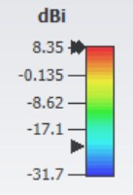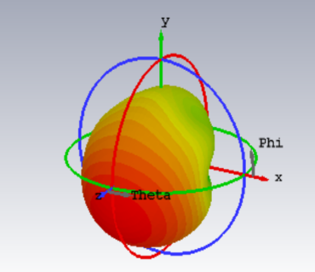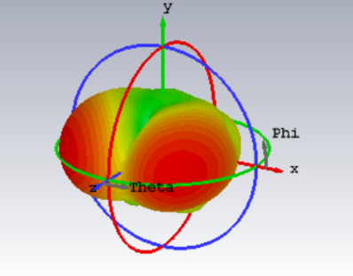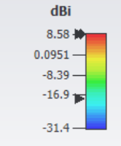

**(A) (B)**

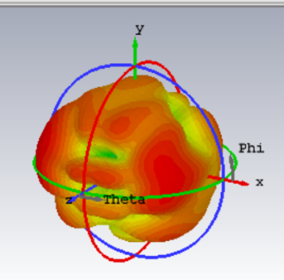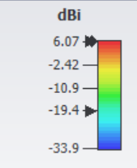

**(C)**

FIGURE 8 Simulated 3D Radiation pattern at (A) 3.14 GHz (B) 4.42 GHz (C) 10.71 GHz

**Conclusion**

A umbrella shaped quad slotted antenna is designed for biomedical applications. The antenna with overall size of 65.2 × 78.2 × 1 mm3 achieves -10dB of impedance bandwidth of 1309 MHz. The designed antenna is suitable for human body. In future, this antenna can be integrated with sensors to perform several multitask applications such as measuring blood pressure, hearth rate and much more.

# REFERENCES

1. T. E. Starner, “Wearable computing for the developing world,” IEEE Pervasive Comput., vol. 4, pp. 87–91, Jul.–Sep. 2005.
2. Dalli A, Zenkouar L, Bri S. Comparison of circular sector and rectangular patch antenna arrays in C-band. J Electromagn Anal Appl. 2012;4(11):457-467. doi:10.4236/jemaa.2012.411064
3. Keshvari J, Keshvari R, Lang S. The effect of increase in dielectric values on specific absorption rate (SAR) in eye and head tissues following 900, 1800 and 2450 MHz radio frequency (RF) exposure. Phys Med Biol. 2006;51(6):1463-1477. doi:10.1088/0031-9155/51/6/007
4. Takebayashi T, Varsier N, Kikuchi Y, et al. Mobile phone use, exposure to radiofrequency electromagnetic field, and brain tumour: a case-control study. Br J Cancer. 2008;98(3):652-659. doi:10.1038/sj.bjc.6604214
5. Jayalakshmi J, Ramesh S. Compact fractal wearable antenna for wireless body area communications. Telecommun Radio Eng. 2020; 79(1):71-80. doi:10.1615/TelecomRadEng.v79.i1.70
6. Annalakshmi T, Ramesh S. Performance and analysis of UWB aesthetic pattern textile antenna for WBAN applications. Appl Comput Electromagn Soc J. 2020;35(12):1525-1531. doi:10.47037/2020.ACES.J.351211
7. Rahman A, Islam MT, Singh MJ, Kibria S, Akhtaruzzaman M. Electromagnetic performances analysis of an ultra-wideband and flexible material antenna in microwave breast imaging: to implement a wearable medical bra. Sci Rep. 2016;6(38906):1-11. doi:10.1038/ srep38906
8. Tighezz M, Rahim SKA, Islam MT. Flexible wideband antenna for 5G applications. Microw Opt Tech Lett. 2018;60(1):38-44. doi:10.1002/ mop.30906
9. Mersani A, Osman L, Ribero J-M. Flexible UWB AMC antenna for early stage skin cancer identification. Progress Electromagn Res M. 2019;80:71-81. doi:10.2528/PIERM18121404
10. Arifin F, Saha PK. Bandwidth enhancement of a compact planar antenna for wireless capsule endoscopy. 2016 9th international confere